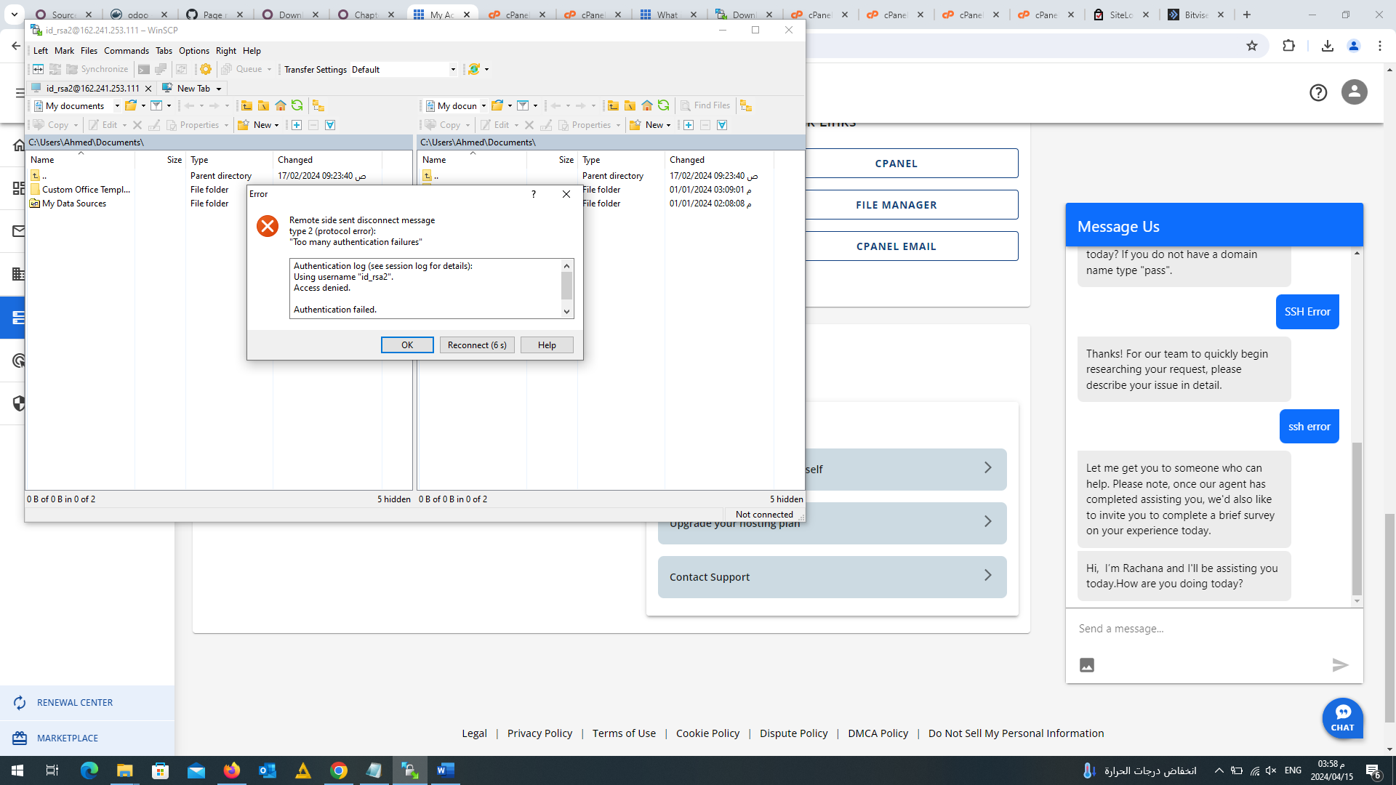

login as: id_rsa2

Server refused our key

id_rsa2@162.241.253.111's password: